Vote Hub: An Style Guidelines for Final Year Project ReportsOnline Election System

Final Year Project Proposal

Session 2016-2020

A 4th Year Student

A project submitted in partial fulfilment of the

COMSATS University Degree

Of

BSc. (Hons.)BS in Computer Science



Department of Computer Science

COMSATS University Islamabad, Lahore Campus

16 May 2020

**Project Registration**

|  |  |  |  |  |  |  |  |
| --- | --- | --- | --- | --- | --- | --- | --- |
| Project ID (for office use) | | |  | | | | |
| Type (Nature of project) | | | [ ] **D**evelopment [ ] **R**esearch [ ] **R**&**D** | | | | |
| Area of specialization | | | Web Based | | | | |
| **Project Group Members** | | | | | | | |
| Sr.# | Reg. # | Student Name | | CGPA | Email ID | Phone # | Signature |
| (i) | FA16-BCS-295 | MUHAMMAD ALI | | 2.47 | [Amuhammad962@gmail.com](mailto:Amuhammad962@gmail.com) | 03084689350 |  |
| (ii) | FA16-BCS-314 | MUHAMMAD RABBI | | 2.54 | [rabbibutt3@gmail.com](mailto:rabbibutt3@gmail.com) | 03314029829 |  |
| Name & Signature of Batch Advisor  (If students are eligible for FYP) | | | |  | | | |

# Plagiarism Free Certificate

This is to certify that, I am MUHAMMAD RABBI BUTT S/O MUHAMMAD ARIF BUTT, group leader of FYP under registration no CIIT/FA16-BCS-314/LHR at Computer Science Department, COMSATS Institute of Information Technology, Lahore. I declare that my FYP proposal is checked by my supervisor and the similarity index is _15% to 18%_ that is less than 20%, an acceptable limit by HEC. Report is attached herewith as Appendix A.

Date: 05/09/2019 Name of Group Leader: _ MUHAMMAD RABBI BUTT Signature: _____________

Name of Supervisor: _SIR ATIF SAEED Co-Supervisor (if any):____________________

Designation: _____________________ Designation: _____________________

Signature: _____________________ Signature: _____________________

**Approval of FYP Management Committee**

Committee Member 1: Name: _____________________

[ ] Accept [ ] *Defer [ ] *Reject Signature: _______________

*Remarks: _____________________________________________________________________

Committee Member 2: Name: _____________________

[ ] Accept [ ] *Defer [ ] *Reject Signature: _______________

*Remarks: _____________________________________________________________________

Convener: Name: _____________________

[ ] Accept [ ] *Defer [ ] *Reject Signature: _______________

*Remarks: _____________________________________________________________________

**Project Abstract suggestion box,**

We are designing a prototype Vote Hub to conduct online elections for any organization according to their need. Vote Hub is a web-based ONLINE ELECTION SYSTEM in which we will give a platform to organizations and users to manage the election system according to their own requirements. We will be providing the easiest way of conducting election to elect a suitable candidate. Voter can cast vote by only one click after logging into the system by inserting their valid credentials. Vote Hub is being designed in such a way that high security techniques are implemented in it to ensure security. Two factors authentication is one of it. Paper polling is a waste of valuable resources like time, paper, and money. Takes lot of effort to manage the election and counting vote. So we introduce the idea to speed up the things in the era of technology avoiding the conventional paper polling elections. Our designed prototype will be tested in COMSATS. This project will be designed by using several programming languages (React, JavaScript, Node, and Mongo DB).

**Introduction**

Some develop countries have already come through the paper polling elections and now working with the technology using online systems for elections. Our goal is to make this trend also applicable in Organizations of Pakistan so that people can ease them self with technology, and an organization can ease them self with the savage of valuable resources like time, money, efforts of managing the elections and counting the votes.

So we came up with Vote Hub which gives a platform for any organization to conduct an election and manage it according to their particular desire which means this system has given the user the freedom to decide the topic of election, limit the number of voters, symbols of candidates, date and time of election, how many candidates are participating and updating the list of candidates and eligible voters in a short span of time. We are testing our designed prototype in COMSATS, where all the eligible voters can cast their vote by just one click after logging into the system by inserting the verified registration ID and password.

Security is also our main component in this project. High security features are being implemented in it. In which we are using latest techniques to secure the system like two factor authentication for the voter so there should be no double casting vote and there will be not any chance of rigging the election.Knowledge factor is used in two factor authentication. The knowledge factor: in security context is a category of authenticating user credentials consisting the information that user possess such as personal Identification number (PIN) or answer to a security question that only user knows. User need to answer that security question in order to pass that authentication process. While registering the vote CODE GENRATOR is used to send a verification code to the voter through text message or through email to verify the original user. These security features verifies the user from all aspects.

Organizations overseas voters can also cast their vote by this online voting system by logging in our system. A suggestion and issue box is provided to the users where people can give suggestions and express their views on different problemsanonymously.

**Motivation and Scope**

Our Motivation and scope is to make easy and reliable election system with advance security features encouraging the democratic culture in Pakistan’s organization. Some organizations have already come through the paper polling elections and now working with the technology using online systems for elections. Our goal is to make this trend also applicable in organizations of Pakistan so that people can ease them self with technology, and an organization can ease them self with the savage of valuable resources like time, money, efforts of managing the elections and counting the votes. So we are here to provide our users all these facilities and security as our first preference in this project. Our first testing target for this project is COMSASTS.

**Related Work**

There is related work on this type of system like election buddy, ECP etc. But some sites are international and have little functionality for Pakistan. And some sites are not secure, have many vulnerabilities on their sites, chances of rigging. And no site is giving the user the liberty to organize their own elections with their desired requirements. There is no proper site which is running in Pakistan providing these kinds of facilities and open hand for the user to organize their own election. This website will help us to bring democratic culture in Pakistan’s organizations.

**Goals and Objectives**

We are in an era of technology where time is money and wastage of resources is a big deal. Providing an environment where everyone is free to choose and express themselves according to the law. It gives people of an organization to not only elect their rightful leaders but also allow them to express their views on different problems. Following are some our goals and objectives which we try to provide and achieve in this project.

.

* We are providing an Election platform for the organizations.
* This platform will help them to save their valuable resources like time, money and cost of management.
* Ensuring the security with two factors authentication.
* Registration ID & Password with a security key.
* Code Generator used to send the verification code
* User has the liberty to organize the election according to their needs.
* Updating the list of candidates and eligible voters in a short span of time.
* Not allowing the double casting of vote.
* Encrypting the voter’s identity and its casted vote.
* Even Admin or Organization organizing the elections has not the access to see the voter’s identity and vote.
* Admin cannot access the result before time.
* Automatic counting of votes.
* Notification system for sending reminders alerts and news about election to the voters.
* Saving of the valuable resources.

**Individual Tasks**

More efforts of Muhammad Ali will be on front end like react, express

More efforts of Muhammad Rabbi Butt will be on back end (Node & Mongo DB)

**Gantt chart**

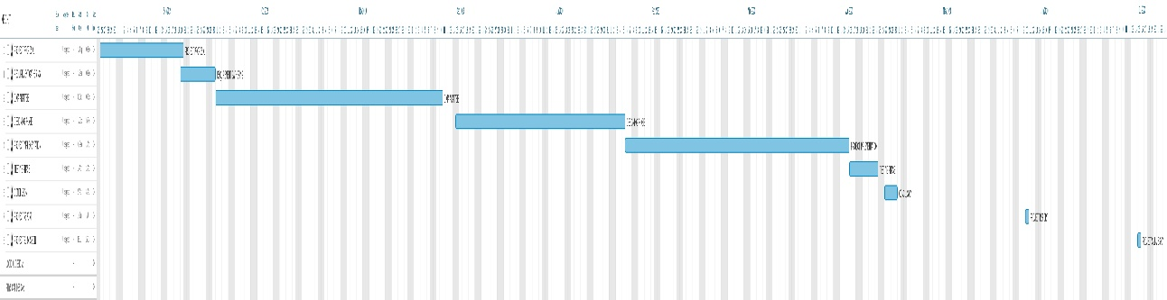

**Tools and Technologies**

**Software Requirement:**

* Visual Studio code
* React js
* Express
* Node js
* Mongo DB

**Plagiarism Report**

